28th ANNUAL
ANCASTER COMMUNITY FOOD DRIVE
ANCASTER FAIRGROUNDS
SATURDAY, MARCH 7, 2020
LEAVE YOUR NON-PERISHABLE FOOD DONATIONS ON YOUR FRONT PORCH BY 9AM
OR
GIVE DONATION TO DOOR-TO-DOOR VOLUNTEER BETWEEN 9AM AND NOON
Record
107,000 lbs
Collected
Last Year!
OR
LEAVE DONATION AT EITHER ONE OF THE TWO ANCASTER FIRE STATIONS BETWEEN FEB 29th AND MARCH 7th

FOR VOLUNTEER AND SPONSORSHIP OPPORTUNITIES AND ON-LINE FINANCIAL DONATIONS
isit www.ancasterfooddrive.ca
VISIT OUR WEBSITE
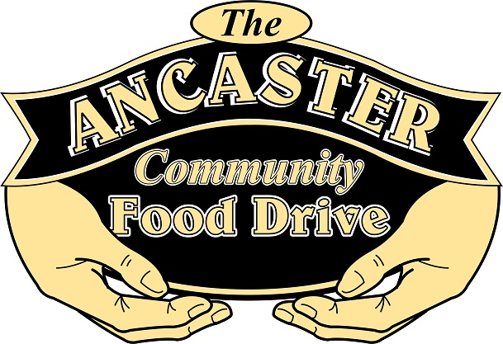
ancastercommunityfooddrive@gmail.com
Thanking the Community of Ancaster for the cumulative total of 1,754,500 LBS of food donated!!!

